**WEEK – 4**

**1. spring-rest-handson**

**Create a Spring Web Project using Maven**

**File Name :** **pom.xml**

<project xmlns="http://maven.apache.org/POM/4.0.0"

xmlns:xsi="http://www.w3.org/2001/XMLSchema-instance"

xsi:schemaLocation="http://maven.apache.org/POM/4.0.0

http://maven.apache.org/xsd/maven-4.0.0.xsd">

<modelVersion>4.0.0</modelVersion>

<groupId>com.cognizant</groupId>

<artifactId>spring-learn</artifactId>

<version>0.0.1-SNAPSHOT</version>

<packaging>jar</packaging>

<name>spring-learn</name>

<description>Demo project for Spring Boot</description>

<parent>

<groupId>org.springframework.boot</groupId>

<artifactId>spring-boot-starter-parent</artifactId>

<version>3.2.5</version>

</parent>

<properties>

<java.version>17</java.version>

</properties>

<dependencies>

<dependency>

<groupId>org.springframework.boot</groupId>

<artifactId>spring-boot-starter-web</artifactId>

</dependency>

<dependency>

<groupId>org.springframework.boot</groupId>

<artifactId>spring-boot-devtools</artifactId>

<scope>runtime</scope>

</dependency>

<dependency>

<groupId>org.springframework.boot</groupId>

<artifactId>spring-boot-starter-test</artifactId>

<scope>test</scope>

</dependency>

</dependencies>

<build>

<plugins>

<plugin>

<groupId>org.springframework.boot</groupId>

<artifactId>spring-boot-maven-plugin</artifactId>

</plugin>

</plugins>

</build>

</project>

**File Name : SpringLearnApplication.java**

package com.cognizant.springlearn;

import org.springframework.boot.SpringApplication;

import org.springframework.boot.autoconfigure.SpringBootApplication;

import org.slf4j.Logger;

import org.slf4j.LoggerFactory;

@SpringBootApplication

public class SpringLearnApplication {

private static final Logger LOGGER = LoggerFactory.getLogger(SpringLearnApplication.class);

public static void main(String[] args) {

LOGGER.info("START");

SpringApplication.run(SpringLearnApplication.class, args);

LOGGER.info("END");

}

}

**File Name : HelloController.java**

package com.cognizant.springlearn;

import org.springframework.web.bind.annotation.GetMapping;

import org.springframework.web.bind.annotation.RestController;

@RestController

public class HelloController {

@GetMapping("/hello")

public String sayHello() {

return "Hello from Spring Boot!";

}

}

**File Name : application.properties**

# Change to an available port

server.port=9191

OUTPUT:

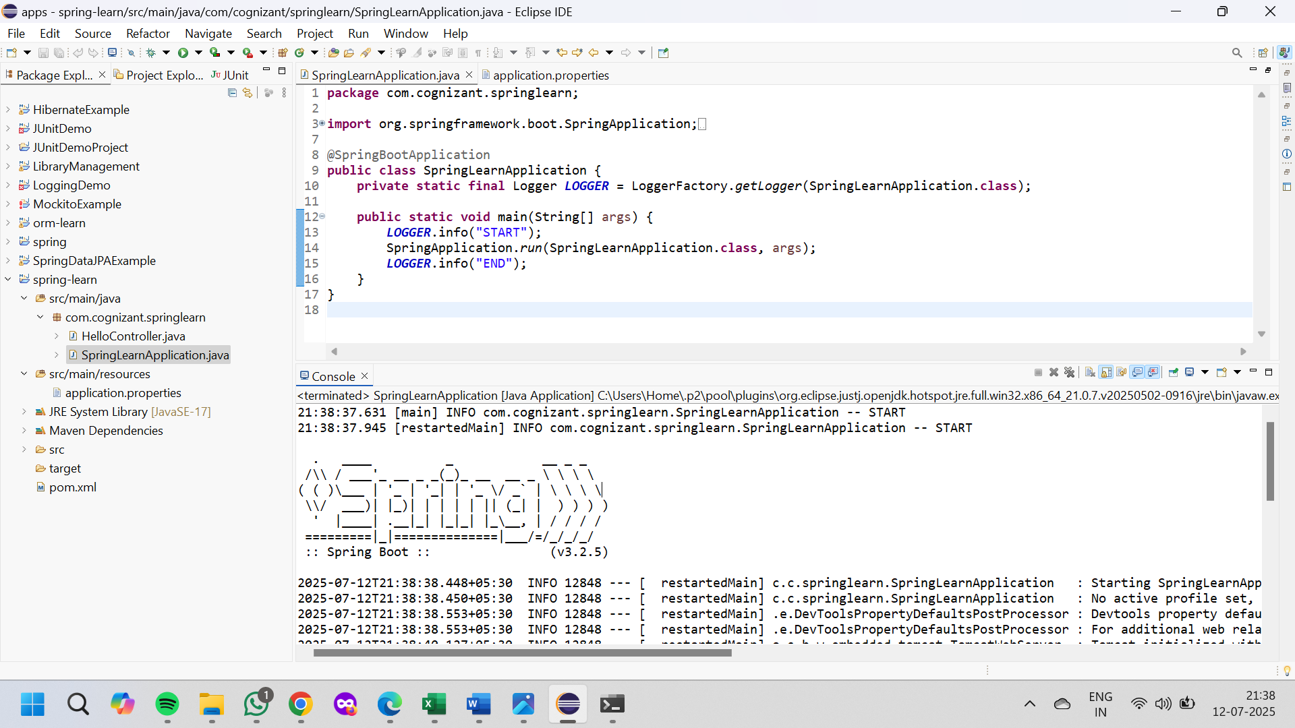

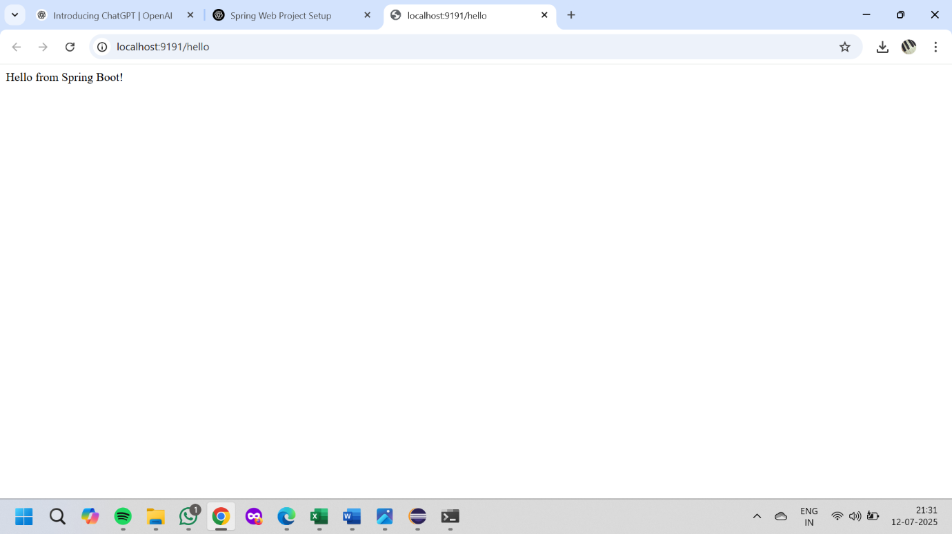

**Spring Core – Load Country from Spring Configuration XML**

**File Name : Country.java**

package com.cognizant.springlearn;

import org.slf4j.Logger;

import org.slf4j.LoggerFactory;

public class Country {

private static final Logger LOGGER = LoggerFactory.getLogger(Country.class);

private String code;

private String name;

public Country() {

LOGGER.debug("Inside Country Constructor.");

}

public String getCode() {

LOGGER.debug("Inside getCode()");

return code;

}

public void setCode(String code) {

LOGGER.debug("Inside setCode()");

this.code = code;

}

public String getName() {

LOGGER.debug("Inside getName()");

return name;

}

public void setName(String name) {

LOGGER.debug("Inside setName()");

this.name = name;

}

@Override

public String toString() {

return "Country [code=" + code + ", name=" + name + "]";

}

}

**File Name:** **country.xml**

<?xml version="1.0" encoding="UTF-8"?>

<beans xmlns="http://www.springframework.org/schema/beans"

xmlns:xsi="http://www.w3.org/2001/XMLSchema-instance"

xsi:schemaLocation="http://www.springframework.org/schema/beans

http://www.springframework.org/schema/beans/spring-beans.xsd">

<bean id="country" class="com.cognizant.springlearn.Country">

<property name="code" value="IN"/>

<property name="name" value="India"/>

</bean>

</beans>

**File:** **SpringLearnApplication.java**

package com.cognizant.springlearn;

import org.slf4j.Logger;

import org.slf4j.LoggerFactory;

import org.springframework.context.ApplicationContext;

import org.springframework.context.support.ClassPathXmlApplicationContext;

public class SpringLearnApplication {

private static final Logger LOGGER = LoggerFactory.getLogger(SpringLearnApplication.class);

public static void displayCountry() {

ApplicationContext context = new ClassPathXmlApplicationContext("country.xml");

Country country = context.getBean("country", Country.class);

LOGGER.debug("Country : {}", country.toString());

}

public static void main(String[] args) {

displayCountry();

}

}

**File Name: pom.xml**

<dependencies>

<!-- Spring Core -->

<dependency>

<groupId>org.springframework</groupId>

<artifactId>spring-context</artifactId>

<version>5.3.30</version>

</dependency>

<!-- SLF4J for Logging -->

<dependency>

<groupId>org.slf4j</groupId>

<artifactId>slf4j-api</artifactId>

<version>1.7.36</version>

</dependency>

<dependency>

<groupId>org.slf4j</groupId>

<artifactId>slf4j-simple</artifactId>

<version>1.7.36</version>

</dependency>

</dependencies>

**OUTPUT:**

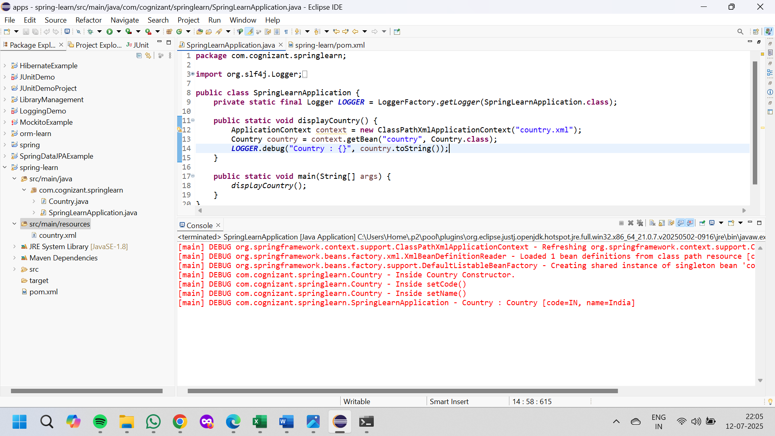

**2. spring-rest-handson**

**Hello World RESTful Web Service**

**File Name : HelloController.java**

package com.cognizant.springlearn.controller;

import org.slf4j.Logger;

import org.slf4j.LoggerFactory;

import org.springframework.web.bind.annotation.GetMapping;

import org.springframework.web.bind.annotation.RestController;

@RestController

public class HelloController {

private static final Logger LOGGER = LoggerFactory.getLogger(HelloController.class);

@GetMapping("/hello")

public String sayHello() {

LOGGER.info("START - sayHello()");

String message = "Hello World!!";

LOGGER.info("END - sayHello()");

return message;

}

}

**File Name : application.properties**

server.port=8083

**OUTPUT:**

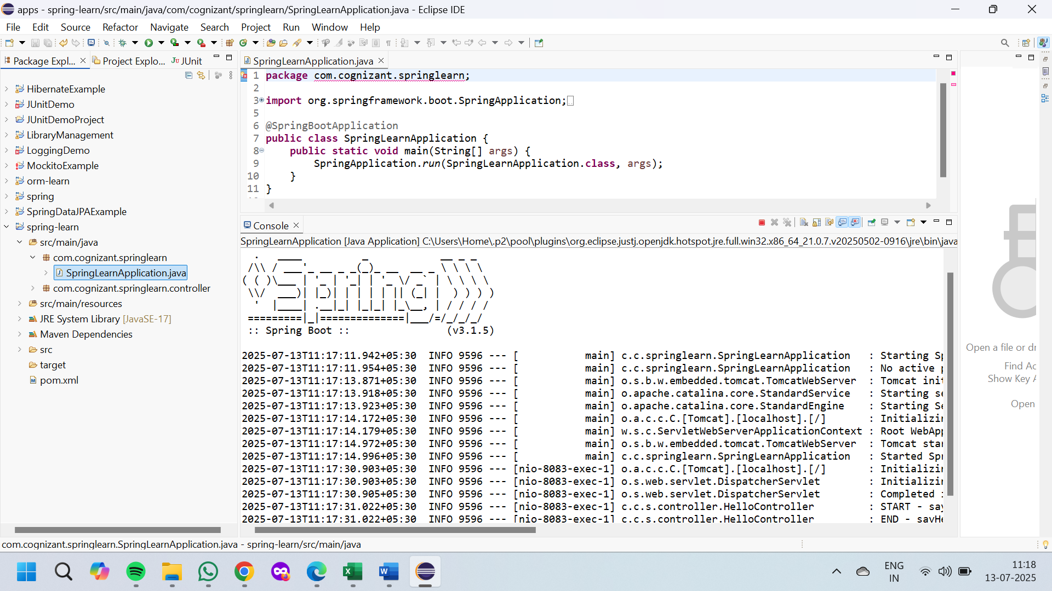

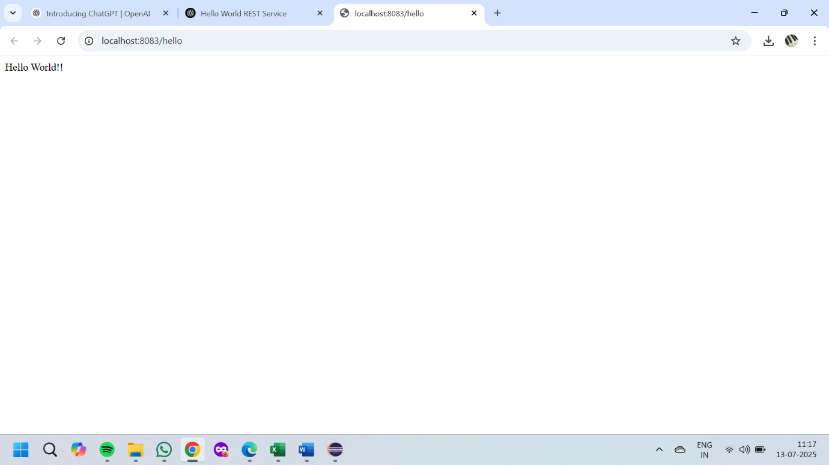

**REST - Country Web Service**

**File Name : SpringLearnApplication.java**

package com.cognizant.springlearn;

import org.springframework.boot.SpringApplication;

import org.springframework.boot.autoconfigure.SpringBootApplication;

@SpringBootApplication

public class SpringLearnApplication {

public static void main(String[] args) {

SpringApplication.run(SpringLearnApplication.class, args);

}

}

File Name : HelloController.java

package com.cognizant.springlearn.controller;

import org.slf4j.Logger;

import org.slf4j.LoggerFactory;

import org.springframework.web.bind.annotation.GetMapping;

import org.springframework.web.bind.annotation.RestController;

@RestController

public class HelloController {

private static final Logger LOGGER = LoggerFactory.getLogger(HelloController.class);

@GetMapping("/hello")

public String sayHello() {

LOGGER.info("START - sayHello()");

String message = "Hello World!!";

LOGGER.info("END - sayHello()");

return message;

}

}

**File Name : CountryController.java**

package com.cognizant.springlearn.controller;

import com.cognizant.springlearn.model.Country;

import org.slf4j.Logger;

import org.slf4j.LoggerFactory;

import org.springframework.context.support.ClassPathXmlApplicationContext;

import org.springframework.web.bind.annotation.RequestMapping;

import org.springframework.web.bind.annotation.RestController;

@RestController

public class CountryController {

private static final Logger LOGGER = LoggerFactory.getLogger(CountryController.class);

@RequestMapping("/country")

public Country getCountryIndia() {

LOGGER.info("START - getCountryIndia()");

ClassPathXmlApplicationContext context = new ClassPathXmlApplicationContext("country.xml");

Country country = (Country) context.getBean("country");

LOGGER.info("END - getCountryIndia()");

return country;

}

}

**File Name : Country.java**

package com.cognizant.springlearn.model;

public class Country {

private String code;

private String name;

public Country() {}

public Country(String code, String name) {

this.code = code;

this.name = name;

}

public String getCode() {

return code;

}

public void setCode(String code) {

this.code = code;

}

public String getName() {

return name;

}

public void setName(String name) {

this.name = name;

}

@Override

public String toString() {

return "Country [code=" + code + ", name=" + name + "]";

}

}

**File Name : application.properties**

server.port=8084

**File Name : country.xml**

<?xml version="1.0" encoding="UTF-8"?>

<beans xmlns="http://www.springframework.org/schema/beans"

xmlns:xsi="http://www.w3.org/2001/XMLSchema-instance"

xsi:schemaLocation="http://www.springframework.org/schema/beans

http://www.springframework.org/schema/beans/spring-beans.xsd">

<bean id="country" class="com.cognizant.springlearn.model.Country">

<property name="code" value="IN"/>

<property name="name" value="India"/>

</bean>

</beans>

**File Name : pom.xml**

<project xmlns="http://maven.apache.org/POM/4.0.0"

xmlns:xsi="http://www.w3.org/2001/XMLSchema-instance"

xsi:schemaLocation="http://maven.apache.org/POM/4.0.0 http://maven.apache.org/xsd/maven-4.0.0.xsd">

<modelVersion>4.0.0</modelVersion>

<groupId>com.cognizant</groupId>

<artifactId>spring-learn</artifactId>

<version>0.0.1-SNAPSHOT</version>

<packaging>jar</packaging>

<name>spring-learn</name>

<parent>

<groupId>org.springframework.boot</groupId>

<artifactId>spring-boot-starter-parent</artifactId>

<version>3.1.5</version>

<relativePath/>

</parent>

<properties>

<java.version>17</java.version>

</properties>

<dependencies>

<dependency>

<groupId>org.springframework.boot</groupId>

<artifactId>spring-boot-starter-web</artifactId>

</dependency>

<dependency>

<groupId>org.springframework.boot</groupId>

<artifactId>spring-boot-starter-logging</artifactId>

</dependency>

</dependencies>

<build>

<plugins>

<plugin>

<groupId>org.springframework.boot</groupId>

<artifactId>spring-boot-maven-plugin</artifactId>

</plugin>

</plugins>

</build>

</project>

**OUTPUT:**



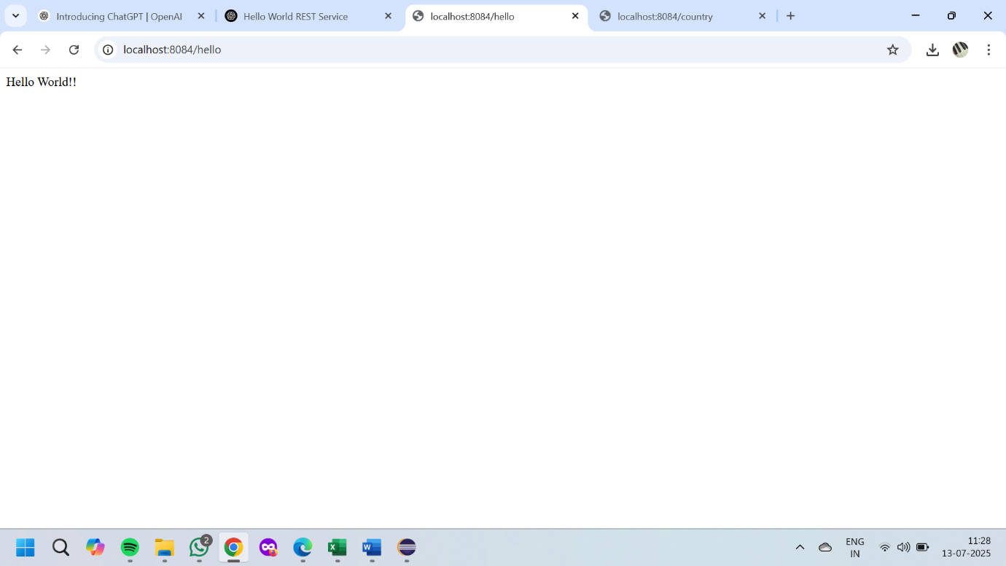

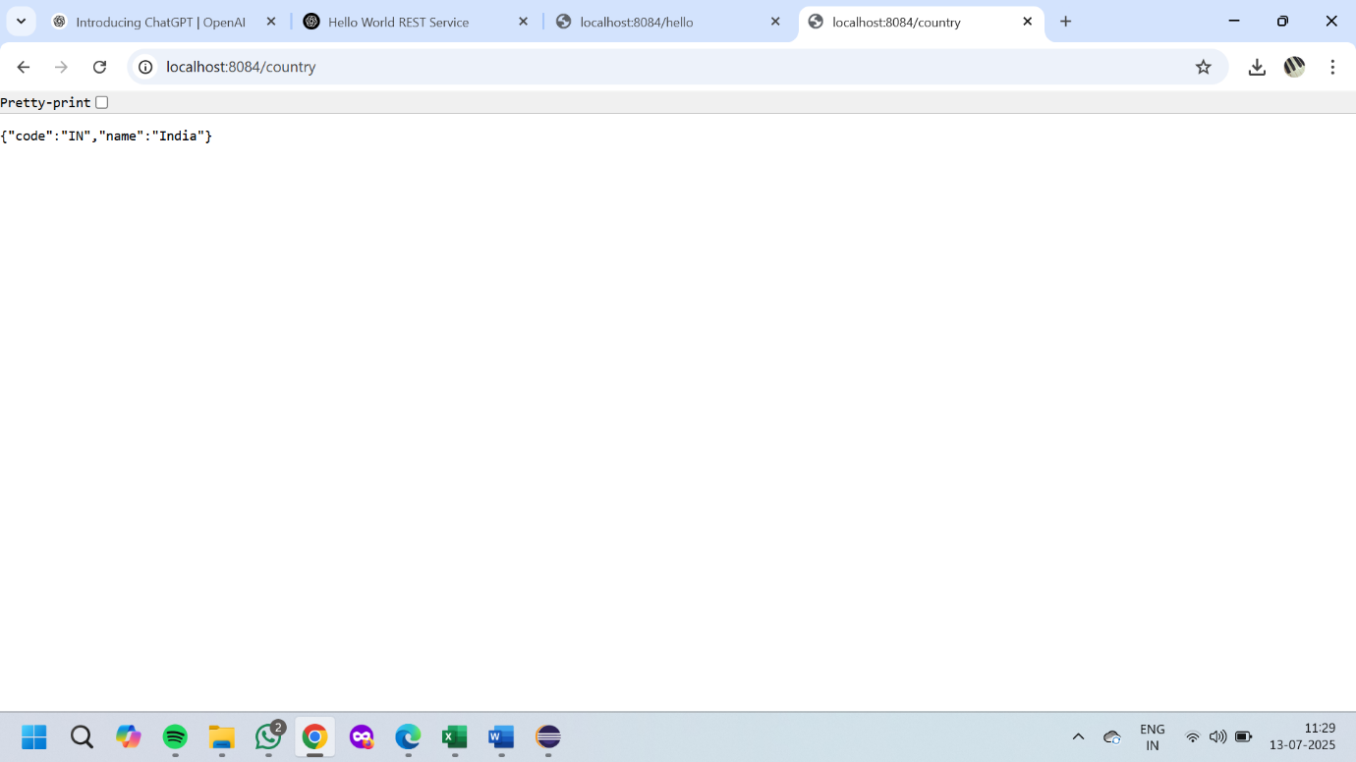

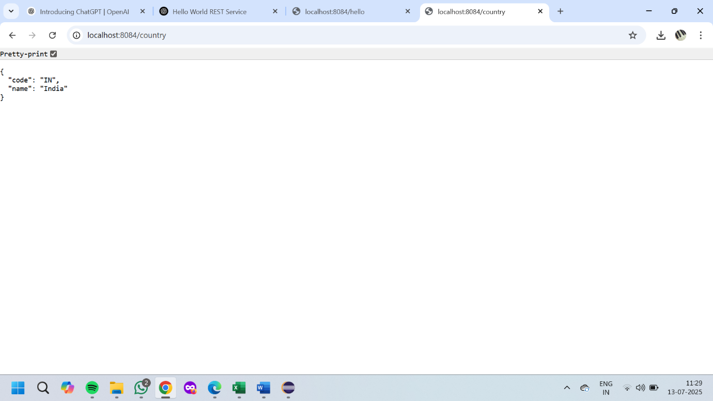

**REST - Get country based on country code**

**File Name : SpringLearnApplication.java**

package com.cognizant.springlearn;

import org.springframework.boot.SpringApplication;

import org.springframework.boot.autoconfigure.SpringBootApplication;

@SpringBootApplication

public class SpringLearnApplication {

public static void main(String[] args) {

SpringApplication.run(SpringLearnApplication.class, args);

}

}

**File Name : HelloController.java**

package com.cognizant.springlearn.controller;

import org.slf4j.Logger;

import org.slf4j.LoggerFactory;

import org.springframework.web.bind.annotation.GetMapping;

import org.springframework.web.bind.annotation.RestController;

@RestController

public class HelloController {

private static final Logger LOGGER = LoggerFactory.getLogger(HelloController.class);

@GetMapping("/hello")

public String sayHello() {

LOGGER.info("START - sayHello()");

String message = "Hello World!!";

LOGGER.info("END - sayHello()");

return message;

}

}

**File Name : CountryController.java**

package com.cognizant.springlearn.controller;

import com.cognizant.springlearn.model.Country;

import com.cognizant.springlearn.service.CountryService;

import org.slf4j.Logger;

import org.slf4j.LoggerFactory;

import org.springframework.beans.factory.annotation.Autowired;

import org.springframework.context.support.ClassPathXmlApplicationContext;

import org.springframework.web.bind.annotation.*;

@RestController

public class CountryController {

private static final Logger LOGGER = LoggerFactory.getLogger(CountryController.class);

@Autowired

private CountryService countryService;

@RequestMapping("/country")

public Country getCountryIndia() {

LOGGER.info("START - getCountryIndia()");

ClassPathXmlApplicationContext context = new ClassPathXmlApplicationContext("country.xml");

Country country = (Country) context.getBean("country");

LOGGER.info("END - getCountryIndia()");

return country;

}

@GetMapping("/country/{code}")

public Country getCountry(@PathVariable String code) {

LOGGER.info("START - getCountry({})", code);

Country country = countryService.getCountry(code);

LOGGER.info("END - getCountry({})", code);

return country;

}

}

**File Name : Country.java**

package com.cognizant.springlearn.model;

public class Country {

private String code;

private String name;

public Country() {}

public Country(String code, String name) {

this.code = code;

this.name = name;

}

public String getCode() {

return code;

}

public void setCode(String code) {

this.code = code;

}

public String getName() {

return name;

}

public void setName(String name) {

this.name = name;

}

@Override

public String toString() {

return "Country [code=" + code + ", name=" + name + "]";

}

}

**File Name : CountryService.java**

package com.cognizant.springlearn.service;

import com.cognizant.springlearn.model.Country;

public interface CountryService {

Country getCountry(String code);

}

**File Name : CountryServiceImpl.java**

package com.cognizant.springlearn.service;

import com.cognizant.springlearn.model.Country;

import org.springframework.context.support.ClassPathXmlApplicationContext;

import org.springframework.stereotype.Service;

import java.util.List;

@Service

public class CountryServiceImpl implements CountryService {

@Override

public Country getCountry(String code) {

ClassPathXmlApplicationContext context = new ClassPathXmlApplicationContext("country.xml");

List<Country> countryList = (List<Country>) context.getBean("countryList");

return countryList.stream()

.filter(c -> c.getCode().equalsIgnoreCase(code))

.findFirst()

.orElse(null);

}

}

**File Name : application.properties**

server.port=8085

**File Name : country.xml**

<?xml version="1.0" encoding="UTF-8"?>

<beans xmlns="http://www.springframework.org/schema/beans"

xmlns:xsi="http://www.w3.org/2001/XMLSchema-instance"

xsi:schemaLocation="http://www.springframework.org/schema/beans

http://www.springframework.org/schema/beans/spring-beans.xsd">

<bean id="country" class="com.cognizant.springlearn.model.Country">

<property name="code" value="IN"/>

<property name="name" value="India"/>

</bean>

<bean id="countryList" class="java.util.ArrayList">

<constructor-arg>

<list>

<bean class="com.cognizant.springlearn.model.Country">

<property name="code" value="IN"/>

<property name="name" value="India"/>

</bean>

<bean class="com.cognizant.springlearn.model.Country">

<property name="code" value="US"/>

<property name="name" value="United States"/>

</bean>

<bean class="com.cognizant.springlearn.model.Country">

<property name="code" value="FR"/>

<property name="name" value="France"/>

</bean>

</list>

</constructor-arg>

</bean>

</beans>

**File Name : pom.xml**

<project xmlns="http://maven.apache.org/POM/4.0.0"

xmlns:xsi="http://www.w3.org/2001/XMLSchema-instance"

xsi:schemaLocation="http://maven.apache.org/POM/4.0.0 http://maven.apache.org/xsd/maven-4.0.0.xsd">

<modelVersion>4.0.0</modelVersion>

<groupId>com.cognizant</groupId>

<artifactId>spring-learn</artifactId>

<version>0.0.1-SNAPSHOT</version>

<packaging>jar</packaging>

<name>spring-learn</name>

<parent>

<groupId>org.springframework.boot</groupId>

<artifactId>spring-boot-starter-parent</artifactId>

<version>3.1.5</version>

<relativePath/>

</parent>

<properties>

<java.version>17</java.version>

</properties>

<dependencies>

<dependency>

<groupId>org.springframework.boot</groupId>

<artifactId>spring-boot-starter-web</artifactId>

</dependency>

<dependency>

<groupId>org.springframework.boot</groupId>

<artifactId>spring-boot-starter-logging</artifactId>

</dependency>

</dependencies>

<build>

<plugins>

<plugin>

<groupId>org.springframework.boot</groupId>

<artifactId>spring-boot-maven-plugin</artifactId>

</plugin>

</plugins>

</build>

</project>

**OUTPUT:**

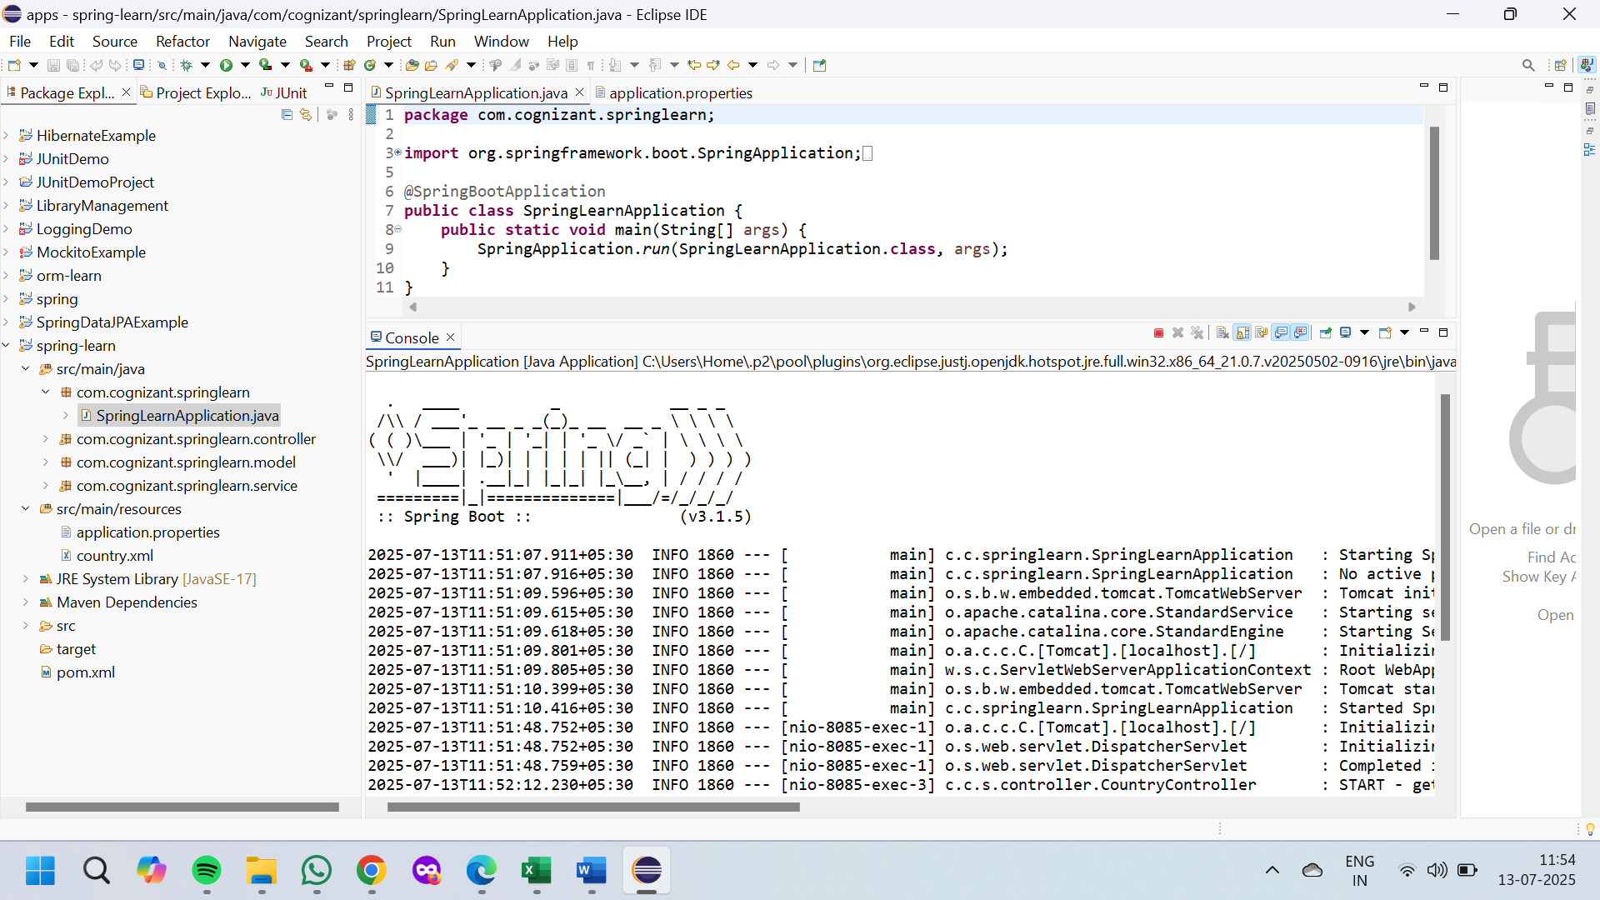

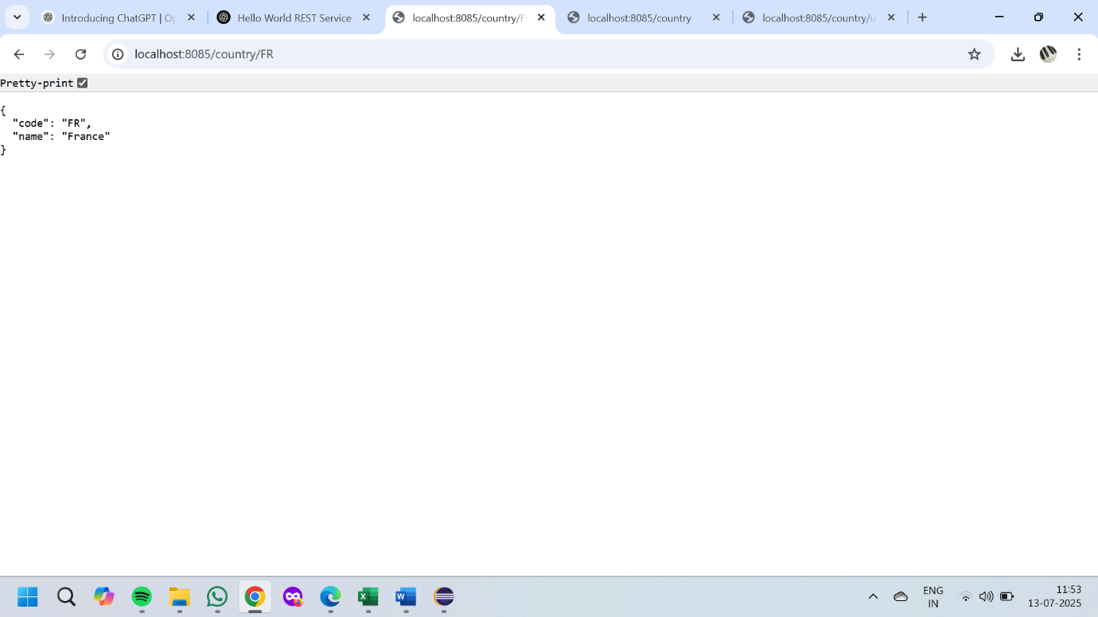

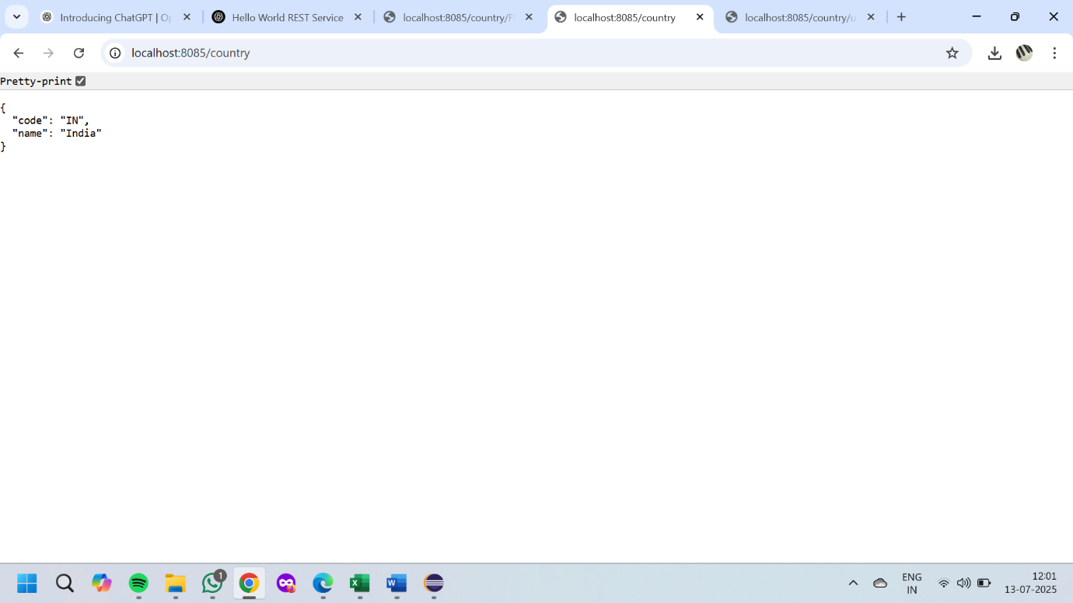

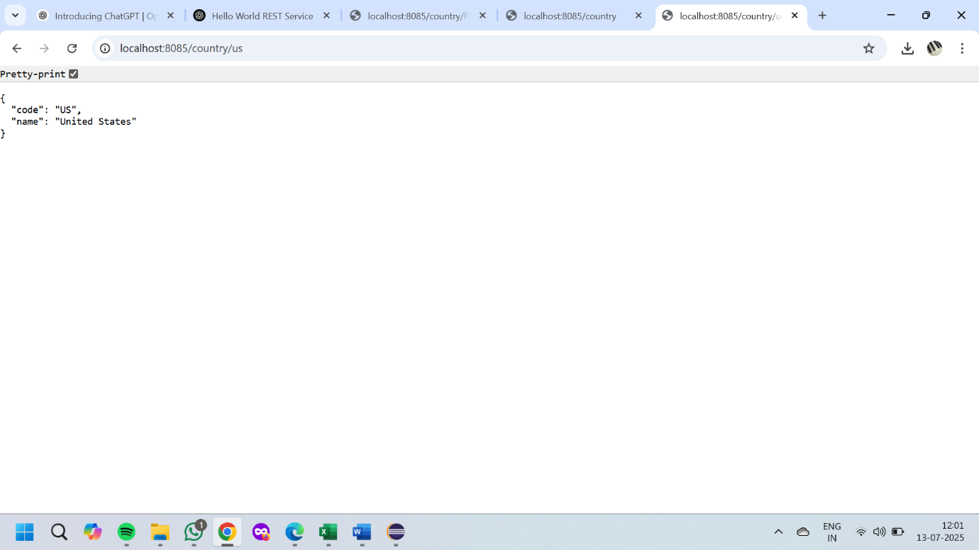

**JWT AUTH SERVICE**

**pom.xml**

<?xml version="1.0" encoding="UTF-8"?>

<project xmlns="http://maven.apache.org/POM/4.0.0" xmlns:xsi="http://www.w3.org/2001/XMLSchema-instance"

xsi:schemaLocation="http://maven.apache.org/POM/4.0.0 https://maven.apache.org/xsd/maven-4.0.0.xsd">

<modelVersion>4.0.0</modelVersion>

<parent>

<groupId>org.springframework.boot</groupId>

<artifactId>spring-boot-starter-parent</artifactId>

<version>3.5.3</version>

<relativePath/> <!-- lookup parent from repository -->

</parent>

<groupId>dev.raseen</groupId>

<artifactId>jwt-auth-serviece</artifactId>

<version>0.0.1-SNAPSHOT</version>

<name>jwt-auth-serviece</name>

<description>jwt-auth-serviece</description>

<url/>

<licenses>

<license/>

</licenses>

<developers>

<developer/>

</developers>

<scm>

<connection/>

<developerConnection/>

<tag/>

<url/>

</scm>

<properties>

<java.version>17</java.version>

</properties>

<dependencies>

<dependency>

<groupId>org.springframework.boot</groupId>

<artifactId>spring-boot-starter-security</artifactId>

</dependency>

<dependency>

<groupId>org.springframework.boot</groupId>

<artifactId>spring-boot-starter-web</artifactId>

</dependency>

<dependency>

<groupId>io.jsonwebtoken</groupId>

<artifactId>jjwt-api</artifactId>

<version>0.11.5</version>

</dependency>

<dependency>

<groupId>io.jsonwebtoken</groupId>

<artifactId>jjwt-impl</artifactId>

<version>0.11.5</version>

<scope>runtime</scope>

</dependency>

<dependency>

<groupId>io.jsonwebtoken</groupId>

<artifactId>jjwt-jackson</artifactId>

<version>0.11.5</version>

<scope>runtime</scope>

</dependency>

<dependency>

<groupId>org.springframework.boot</groupId>

<artifactId>spring-boot-starter-test</artifactId>

<scope>test</scope>

</dependency>

<dependency>

<groupId>org.springframework.security</groupId>

<artifactId>spring-security-test</artifactId>

<scope>test</scope>

</dependency>

</dependencies>

<build>

<plugins>

<plugin>

<groupId>org.springframework.boot</groupId>

<artifactId>spring-boot-maven-plugin</artifactId>

</plugin>

</plugins>

</build>

</project>

**JwtAuthServiceApplication.java**

package dev.raseen.jwtauthserviece;

import org.springframework.boot.SpringApplication;

import org.springframework.boot.autoconfigure.SpringBootApplication;

@SpringBootApplication

public class JwtAuthServieceApplication {

public static void main(String[] args) {

SpringApplication.run(JwtAuthServieceApplication.class, args);

}

}

**JwtUtil.java**

package dev.raseen.jwtauthserviece;

import io.jsonwebtoken.Jwts;

import io.jsonwebtoken.security.Keys;

import org.springframework.stereotype.Component;

import java.security.Key;

import java.util.Date;

@Component

public class JwtUtil {

private static final Key SECRET_KEY = Keys.hmacShaKeyFor(

"mySuperSecretKeyForJwtSigningMustBeLongEnough!".getBytes()

);

public String generateToken(String username) {

return Jwts.builder()

.setSubject(username)

.setIssuedAt(new Date())

.setExpiration(new Date(System.currentTimeMillis() + 1000 * 60 * 10))

.signWith(SECRET_KEY)

.compact();

}

}

**SecurityConfig.java**

package dev.raseen.jwtauthserviece;

import org.springframework.context.annotation.Bean;

import org.springframework.context.annotation.Configuration;

import org.springframework.security.config.annotation.web.builders.HttpSecurity;

import org.springframework.security.config.Customizer;

import org.springframework.security.config.annotation.web.configurers.AbstractHttpConfigurer;

import org.springframework.security.core.userdetails.User;

import org.springframework.security.core.userdetails.UserDetailsService;

import org.springframework.security.provisioning.InMemoryUserDetailsManager;

import org.springframework.security.web.SecurityFilterChain;

@Configuration

public class SecurityConfig {

@Bean

public SecurityFilterChain filterChain(HttpSecurity http) throws Exception {

http.csrf(AbstractHttpConfigurer::disable)

.authorizeHttpRequests(auth -> auth

.requestMatchers("/authenticate").authenticated()

.anyRequest().denyAll()

)

.httpBasic(Customizer.withDefaults());

return http.build();

}

@Bean

public UserDetailsService users() {

return new InMemoryUserDetailsManager(

User.withUsername("user")

.password("{noop}pwd")

.roles("USER")

.build()

);

}

}

**AuthController.java**

package dev.raseen.jwtauthserviece;

import org.springframework.security.core.Authentication;

import org.springframework.web.bind.annotation.GetMapping;

import org.springframework.web.bind.annotation.RestController;

import java.util.Map;

@RestController

public class AuthController {

private final JwtUtil jwtUtil;

public AuthController(JwtUtil jwtUtil) {

this.jwtUtil = jwtUtil;

}

@GetMapping("/authenticate")

public Map<String, String> authenticate(Authentication authentication) {

String token = jwtUtil.generateToken(authentication.getName());

return Map.of("token", token);

}

}

**OUTPUT:**

